Extended Abstract

Title of Your Manuscript Should Describe the Intervention: Study Design

Abstract
Background:
Objective:
Methods:
Results: Be sure to include relevant statistics here, such as sample sizes, response rates, P values or Confidence Intervals. Be specific (by stating the value) rather than general (eg, “there were differences between the groups”).
Conclusions:
Trial Registration: In accordance with ICMJE recommendations, RCTs must have been registered in a WHO accredited trial registry. Please mention the ClinicalTrials.gov registration identifier, the International Standard Randomized Controlled Trial Number (ISRCTN), or a comparable trial identifier at the end of the abstract ("Trial Registration: ClinicalTrials.gov NCT123456"), as well as when you first mention the trial in the manuscript. When mentioning related trials (e.g. in the Introduction or Methods section) the trial registration number should also be added in brackets. ICMJE member journals require, as a condition of consideration for publication, registration in a public trials registry at or before the onset of patient enrollment. This policy applies to any trial which started enrollment after July 1, 2005. JMIR authors must add an explanation to the methods section of their manuscript if a RCT meeting these criteria has not been registered. The JMIR editor reserves the right to reject any paper without trial registration without any further consideration or peer-review.

Keywords: Provide 3 to 10 keywords or short phrases separated with semicolons (;) that will assist indexers in cross-indexing the article and that may be published with the abstract.

Introduction
This section can include background information such as theories, prior work, and hypotheses.

If this section is quite lengthy, use of subheadings are encouraged to break up the material logically. Subheadings should be consistent; therefore a subheading for the first part of the Methods section, for example, is also necessary (see below).

Generally, an extended abstract should be 5 pages long using this template, including. Papers should be written in accordance with the American Medical Association Manual of Style: A Guide for Authors and Editors. 9th ed. Baltimore, Md: Williams & Wilkins; 1998.

Please do not include URLs within the manuscript. A reference should be created for the URL and included in the reference list. Please use WebCite [1] to capture the website as soon as possible, as they often expire after the intervention and become inaccessible. The WebCite ID should be mentioned in the reference [13].

Methods

Intervention
If your paper describes an electronic intervention, you are highly encouraged to provide a screenshot as figure. The figures should be included in the manuscript and also uploaded as JPG or PNG file in the submission system (Figure 1).

Figure 1. Uploaded figures in the submission system. Captions/titles are inserted online. Try to use Times New Roman for text within the Figure to match the font of the final typeset manuscript when possible. These should be .jpeg or .png files. Please prepare Figures with good resolution – Figures that are predominantly graphics/pictures should have dpi close to 300, while those that are text-dominant can have lower resolution (usually dpi 200). Try to use combinations of color and symbols/line styles to define and refer to different categories. This will help with readability if Figures are printed/viewed in black and white.
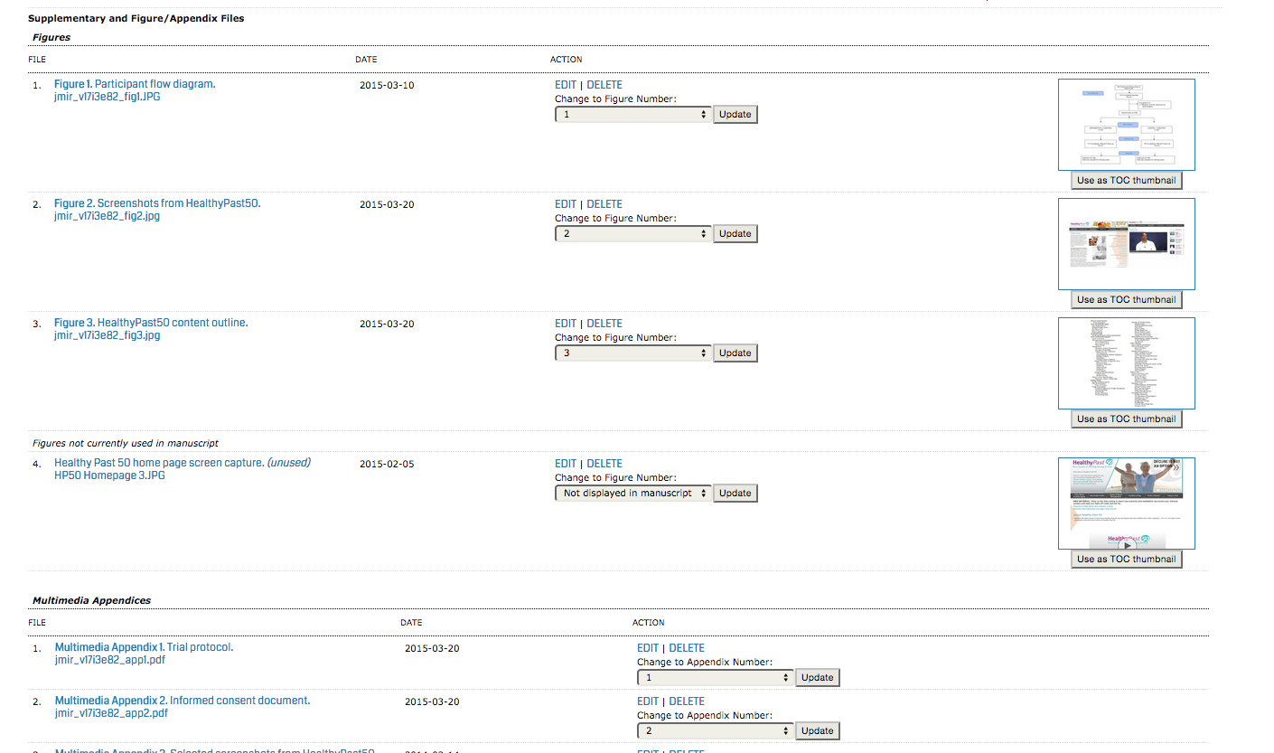

Participants and Recruitment
Notice that the first subheading immediately follows the last heading. Subheadings under subheadings are also possible (see Statistical Analysis).

Statistical Analysis

Power
Notice that the next Heading Style (Heading Style 4 in this case) is used. Click on the different headings to see their Heading Style in the “Home” ribbon under “Styles”. Always have at least 2 of the same subheading level in a section.

Data Exclusion
Try to avoid having only one sentence after a subheading. For example, describe the key findings of a Table that you refer to in that sentence.

Results

User Statistics
These are only examples of possible headings. Please feel free to use different headings to best describe your results.

Evaluation Outcomes
Please make reference to your Textboxes (Textbox 1), Tables (Table 1), Figures (Figure 1), and Multimedia Appendices (Multimedia Appendix 1) in parenthesis. Please see the examples below for how they should be formatted. Please note the punctuation used in all components, including the caption/title, footnotes etc.

Figures and Multimedia Appendices are uploaded online, while Textboxes and Tables are not uploaded and remain in the body of the manuscript, appearing in the order they are mentioned after the first mention of each Table.

Textbox 1. The caption/title is placed here in a sentence format (capitalization of every word is unnecessary).
- The formatting is actually a 1x1 Table, not an actual “textbox”.
- Textboxes have no footnotes.
- Bullet points or numbered lists are allowed in textboxes.

Table 1. The table caption/title is placed here in a sentence format (capitalization of every word is unnecessary).
 |  | Main heading 1 | Main heading 1 | Main heading 1
 |  | Main heading 2 | Main heading 2 | Main heading 2e
Category Headingª
(leave blank) | Male | data | data | data
(leave blank) | Female | data | data | data
Category Heading
(leave blank) |  | data | data | <.001
(leave blank) |  | data | data | n.a. ^{f}
Category Heading
(leave blank) |  | data | data | data
(leave blank) |  | data | data | data
ªNot all elements are necessary for every table, simply omit the irrelevant sections for your table and keep the formatting of the rest. For further details, please refer to the main Instructions for Authors of JMIR document.
^{b}Footnotes are labeled in superscript lower case a-z. Other symbols are not used.
^{c}Astericks (*) can only be used if exact P values cannot be provided for a specific reason, and are listed after the superscript a-z footnotes.
^{d}please be conscious of the overall width of the table. Tables will be automatically fitted/resized to the width of a US Letter Small page in portrait configuration during typesetting. Overcrowded Tables or Tables that are too crowded WILL look squished, and should be avoided if possible.
^{e}longer headings can be abridged within the Table, with a full explanation in a footnote.
^{f}missing values or “non applicable” should usually be explained in a footnote.

Discussion

Principal Results
Discussion usually starts with a summary of the main findings. But these subheadings are just examples – no absolute need to follow this structure.

Comparison with Prior Work
Contextualize your work.

Limitations
Be forthcoming about the limitations, methodological problems etc.

Future Work
What will you do, what should others do to advance the field.

Conclusions

Acknowledgements
Please include all authors’ contributions, funding information, financial disclosure, role of sponsors, and other acknowledgements here. This description should include the involvement, if any, in review and approval of the manuscript for publication and the role of sponsors. Omit if not applicable.

Conflicts of Interest
Disclose any personal financial interests related to the subject matters discussed in the manuscript here. For example, authors who are owners or employees of Internet companies that market the services described in the manuscript will be disclosed here. If none, indicate with “none declared”.

Abbreviations
JMIR: Journal of Medical Internet Research
RCT: randomized controlled trial

Multimedia Appendix 1
Multimedia appendices are supplementary files, such as a PowerPoint presentation of a conference talk about the study, additional screenshots of a website, mpeg/Quicktime video/audio files, Excel/Access/SAS/SPSS files containing original data (very long tables), and questionnaires. Do not include copyrighted material unless you obtained written permission from the copyright holder, which should be faxed to the editorial office in case of acceptance together with your Publication Agreement form.

The Multimedia Appendices must be uploaded online, accompanied by a caption. CONSORT-EHEALTH checklists are always uploaded as Multimedia Appendices. Although this is primarily intended for randomized trials, the section of the checklist describing how an intervention should be reported is also relevant for manuscripts with other evaluation designs.
Before submission, authors of RCTs must fill in the electronic CONSORT-EHEALTH questionnaire at http://tinyurl.com/consort-ehealth-v1-6 with quotes from their manuscript (if you wish to comment on the importance of the items from the checklist for reporting, please also rate each item on a scale between 1-5). BEFORE you press submit, please generate a pdf of the form with your responses and upload this file as supplementary file entitled CONSORT-EHEALTH V1.6.

References
- WebCite http://www.webcitation.org
- Number references using 1., 2., 3. etc (no square brackets) corresponding to the square bracketed references (eg, [1], [2,3], [4-7]) in the body of the manuscript.
- DO NOT use italics, periods after authors’ initials, and periods after journal abbreviations.
- DO use a semicolon (;) after a journal title before the year, put volume number in parenthesis, and use a colon (:) before the page numbers.
- Titles should be in sentence case (do NOT capitalize the first letter of every word).
- Do not use the footnotes tool to generate the reference list.
- Cite only published or accepted (“in print”) works. Submitted papers (not accepted) documents not widely available (personal emails, letters), or oral communications (unless they are published abstracts) should NOT be cited as references. Cite these in the main body of text as “personal communication by NAME, DATE” after obtaining permission from the communicator to quote his communication.
- Remove OLE elements from reference management softwares such as Endnote and Reference Manager. Select the entire document (Ctrl+A or Command A), remove field codes (Ctrl+Shift+F9 or Command+6). This is important for correct parsing of your reference list using RefCheck during copyediting. This is an automatic process, but please check for completeness and accuracy of parsed fields for each reference when prompted during copyediting steps after acceptance of your manuscript.
- Journal Articles (examples following): append the PubMed Identifier (PMID, eg, "PMID:1234567", where 1234567 is the PubMed identifier) or DOI (digital object identifier, eg, doi:10.1136/bmj.331.7529.1391) after each reference. Alternatively (as per our old instructions) you could append a [Medline] link after each reference, linking to the PubMed abstract of the article you are citing. You may check whether a DOI is correct using the DOI resolver at http://dx.doi.org/.
- International Committee of Medical Journal Editors. Uniform requirements for manuscripts submitted to biomedical journals. JAMA 1997;277:927-934. PMID:9062335
- International Committee of Medical Journal Editors. Uniform requirements for manuscripts submitted to biomedical journals. JAMA 1997;277:927-934. [Medline]
- Websites and Web articles (URLs) (example following) should be cited as "webcited®" references in the reference section at the end of the manuscript - do not include links to websites in the text. To webcite® a web reference means to take a snapshot of the cited document and to cite the archived copy (WebCite link) in addition to the original URL. JMIR now requires that authors use the WebCite ® technology (www.webcitation.org) to archive cited web references first before they cite them. Do not cite uncached "live" webpages and websites in the article or reference section, unless archiving with WebCite has failed. Provide both the original URL and the WebCite link. Note that journal articles in electronic formats are journal articles, not a web reference.
- Fox S, Fallows D. 2003. Internet Health Resources. http://www.pewinternet.org/pdfs/PIP_Health_Report_July_2003.pdf. Archived at: http://www.webcitation.org/5I2STSU61
- For books, please add the ISBN, if known (no blanks). (http://isbndb.com/; examples below)
- Iverson CL, Flanagin A, Fontanarosa PB, et al. American Medical Association Manual of Style: A Guide for Authors and Editors. 9th edition. Baltimore, Md: Williams & Wilkins; 1998. ISBN:0195176332
- Phillips SJ, Whisnant JP. Hypertension and stroke. In: Laragh JH, Brenner BM, editors. Hypertension: pathophysiology, diagnosis, and management. 2nd ed. New York: Raven Press; 1995. p. 465-78.
- Conference Proceedings (example below). If conference proceedings are available through Medline, please use the Medline citation.
- Kimura J, Shibasaki H, editors. Recent advances in clinical neurophysiology. Proceedings of the 10th International Congress of EMG and Clinical Neurophysiology; 1995 Oct 15-19; Kyoto, Japan. Amsterdam: Elsevier; 1996.

